

Project Report of

Library Management

System

By

|  |
| --- |
| **Pritam Saha Keerthi – 15-29742-2**  **Nasimul Hasan - 16-32415-2**  **Salman Al Mamun – 15-29726-2**  **Anim Bhuiya - 16-31114-1** |

|  |
| --- |
| Subject: Introduction to Database  Section: F |

**Table Of content**

**Introduction,**

1. Scenario
2. Entity-Relationship Diagram
3. Normalization
4. Table Creation:
5. Insertion:
6. Queries:

**Conclusion**

**References.**

**Introduction:**

Library Management system is a system where we can store the information of the library books, students who borrow them and the staff who handles the books. It stores data to that we can easily access the management of the library.

**Scenario**

A University Library has a lot of books for their Students who can borrow books for their study. The books have a unique ID, name and others. The Students has a unique, name, address & gender. The Students came from a department which have a unique ID. The students can borrow one or many book at a time from the library . The students have to issue the books in order to borrow them. Students can issue one book at a time . The books has an issue date, return date. The students have to return the books before the expiry date. The library has some staff who can be identified by their unique staff ID. They manage the books on the library. One staff has to manage many books at a time.

**Entity-Relationship Diagram**

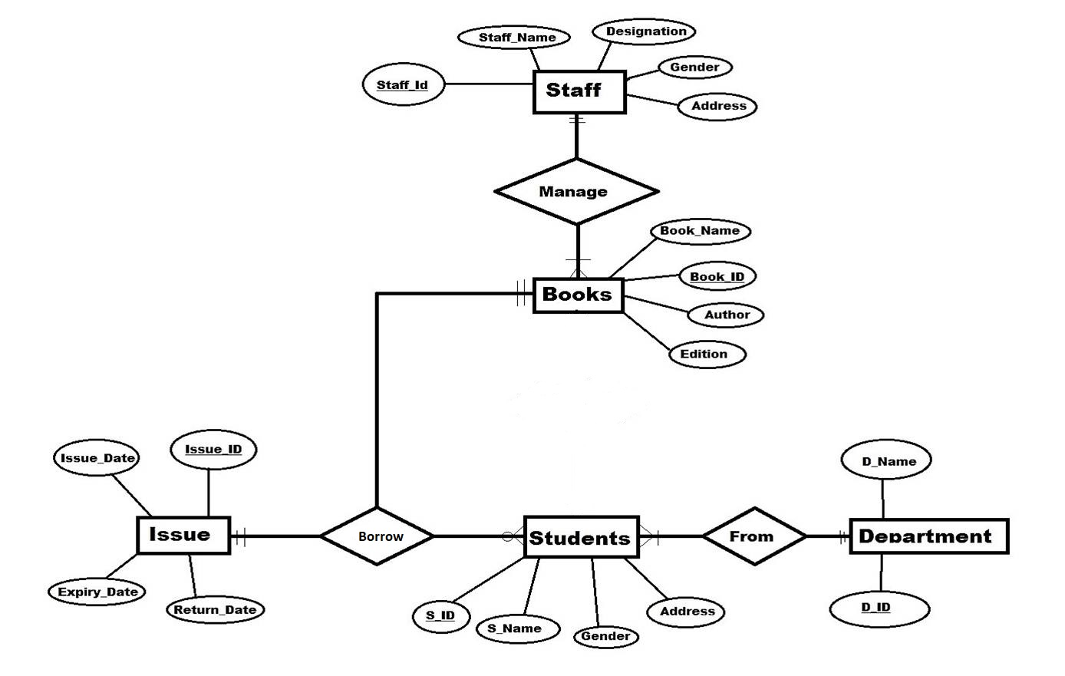

**Normalization**

For Normalization we first separated the whole table into one table and the end table attributes are:

*Book_ID, Book_Name, Author, Edition, S_ID, S_name, S_Address, s_gender, D_Name, D_id, Issu_date, Return_date, Expiry_Date, Issue_ID, Staff_name, Staff_id, Designation, stf_address.*

After This procedure we applied the 1st Normalization form. But the table doesn’t follow the 1Nf formula as there ia no repeating data in the table.

After this procedure we applied 2Nf or 2nd Normalization Method to remove partial dependency. And so the end tables are:

*Tab 1: Book_ID, Book_Name, Edition, Author.*

*Tab 2: S_ID, S_name, S_Address, s_gender*

*Tab 3: D_id, D_Name,*

*Tab 4: Issue_ID ,Issu_date, Return_date, Expiry_Date,*

*Tab 5 : , Staff_id, Staff_nameDesignation, stf_address.*

Then we applied the 3NF or 3rd Normalization method. As there in no Transitive Dependency, it doesn’t follow 3NF method. And the end tables are:

*Books: Book_ID, Book_Name, Edition, Author.*

*Student: S_ID, S_name, S_Address, s_gender*

*Department: D_id, D_Name,*

*Issue: Issue_ID ,Issu_date, Return_date, Expiry_Date,*

*Staff : Staff_id, Staff_nameDesignation, stf_address.*

**Table Creation:**

First We created the the tables :

Department table :

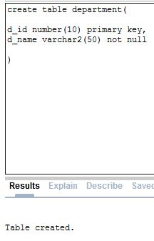

Student :

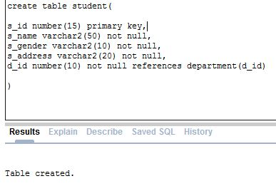

Book:

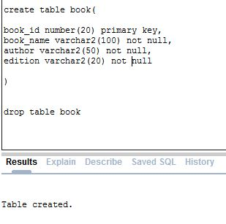

Staff:

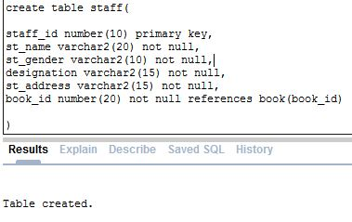

Issue:

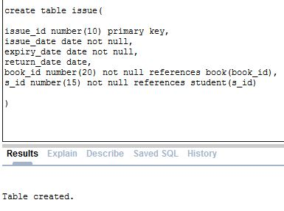

**Insertion:**

**Department:**

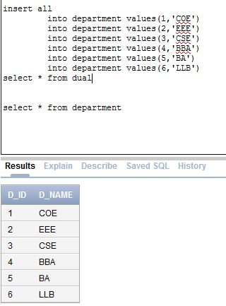

**Student:**

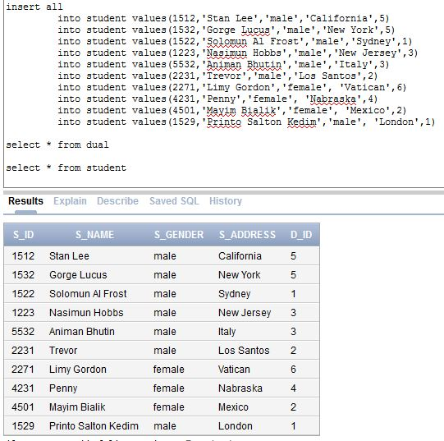

**Book:**

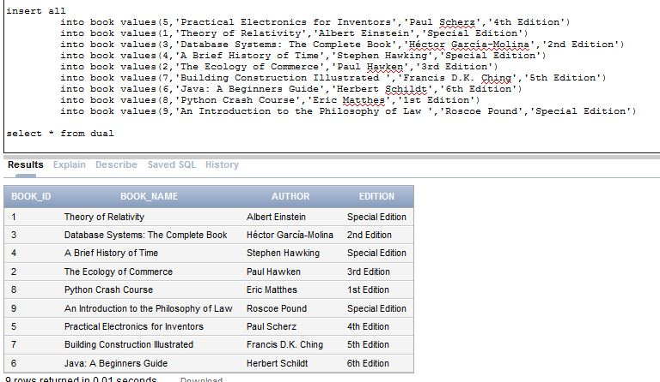

**Staff:**

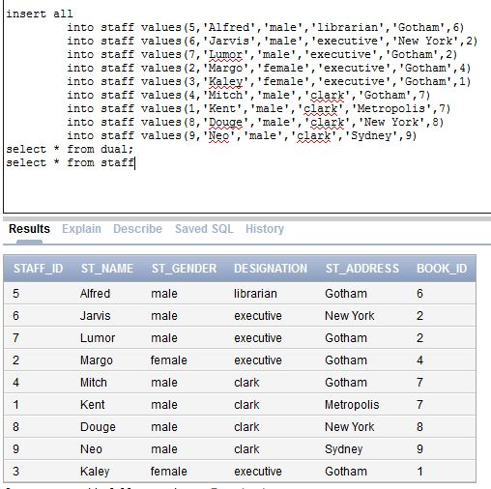

**Issue:**

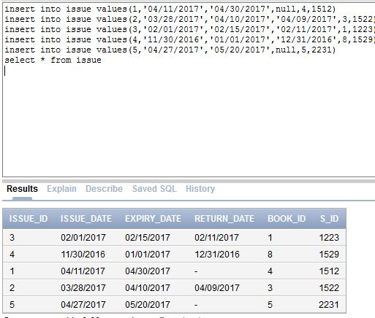

**Queries:**

**Joining**

* **Show the details of the students who borrowed books from the library**

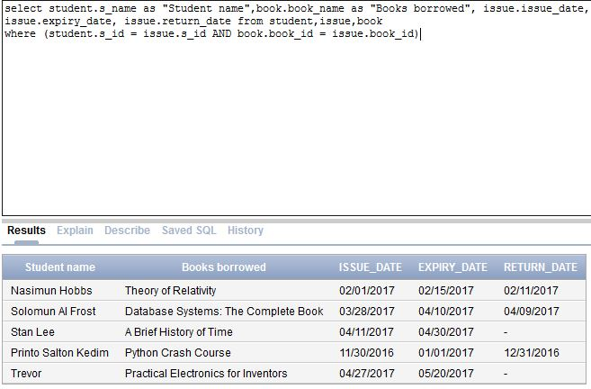

* **Show what book is borrowed by “Printo Salton Kedim” . Also find out when did he borrowed and when did he returned the book in a sentence.**

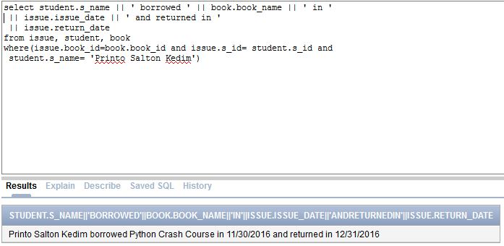

**Subquery:**

* **Find the the name of the student who borrowed book number 1 and show the name of the book and return date.**

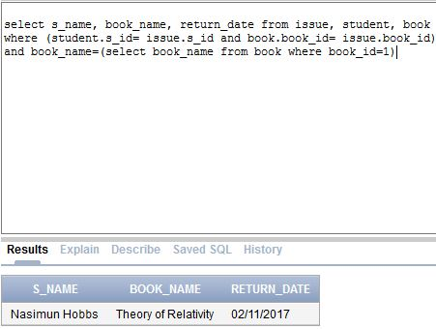

* **Find the name of the students who borrowed books and the expiry date of returning the books is not finished.**

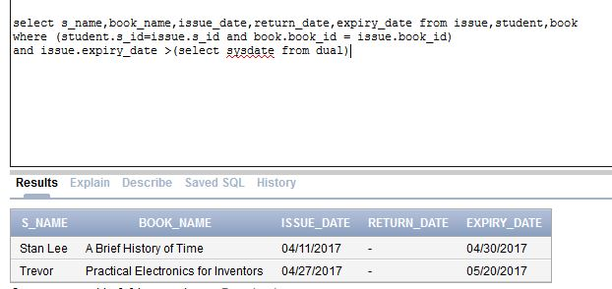

**View:**

* **Create a Table bookshelf as view from table book and include the book names and ediion**

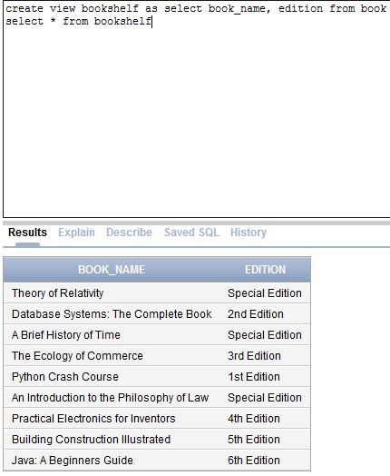

**Conclusion:**

The project was successfully completed the required queries were executed properly.

**References:**

**[1]** <https://www.w3schools.com>

**[2]** stackoverflow.com

**[3]** https://www.tutorialspoint.com/ms_sql_server/